PROJECT REPORT

1 . INTRODUCTION

* 1. Overview
* India is the world's third-largest producer and third-largest consumer of electricity. The national electric grid in India has an installed capacity of 370.106 GW as of 31 March 2020. Renewable power plants, which also include large hydroelectric plants, constitute 35.86% of India's total installed capacity. During the fiscal year (FY) 2019–20, the total electricity generation in the country was 1,598 TWh, of which 1,383.5 TWh generated by utilities. The gross electricity consumption per capita in FY2019 was 1,208 kWh. In 2015-16, electric energy consumption in agriculture was recorded as being the highest (17.89%) worldwide. The per capita electricity consumption is low compared to most other countries despite India having a low electricity tariff.
* Analysing Electricity Consumption in India from Jan 2019 till 5 th December 2020. This dataset contains a record of Electricity consumption in each states of India, here we are going to analyse State wise , Region wise and Overall Electricity consumption in India.
  1. Purpose
* Analyzing analysis on electricity consumption in India Identify the current patterns of electricity consumption in different regions and sectors of India. This information can be used to identify areas where consumption is high and areas where it is low. Identify opportunities for improving energy efficiency and reducing consumption in different sectors and regions. This information can be used to develop policies and programs to promote energy efficiency. This information can be used by government agencies, electricity providers, and investors to develop policies and make investment decisions that promote sustainable energy development and consumption in India.
* The analysis can help to improve the quality of life for people living in areas without access to electricity, including providing access to lighting, heating, and cooling, and powering essential services such as hospitals and schools.

2. PROBLEM DEFINITION AND DESIGN THINKING

2.1 Empathy map

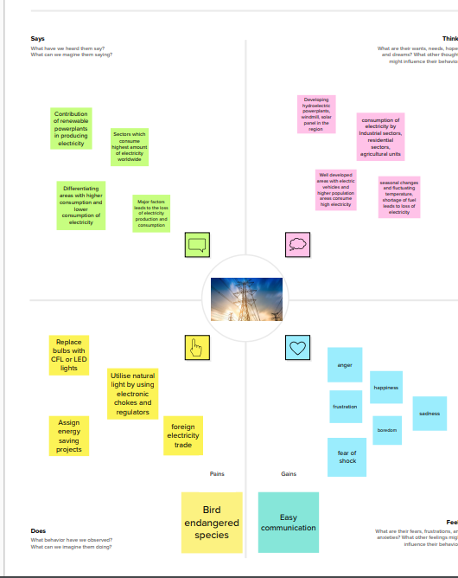

2.2 Ideation and Brainstorming Map

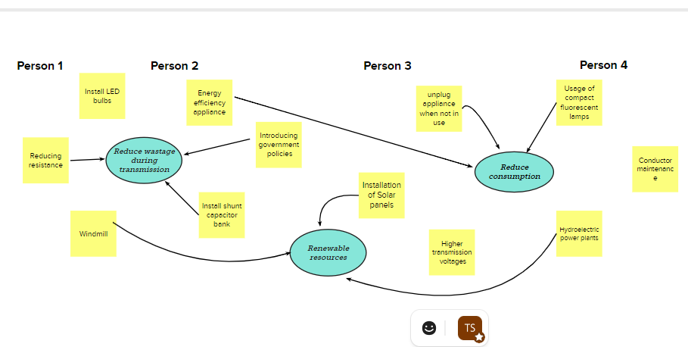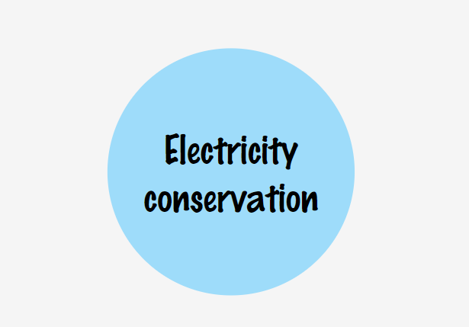

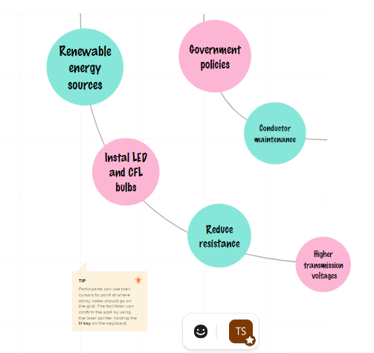

3. RESULT

With the final outputs of the visualizations we were able to analyse the statewise , regionwise and overall consumption of electricity in India.

DASHBOARDS

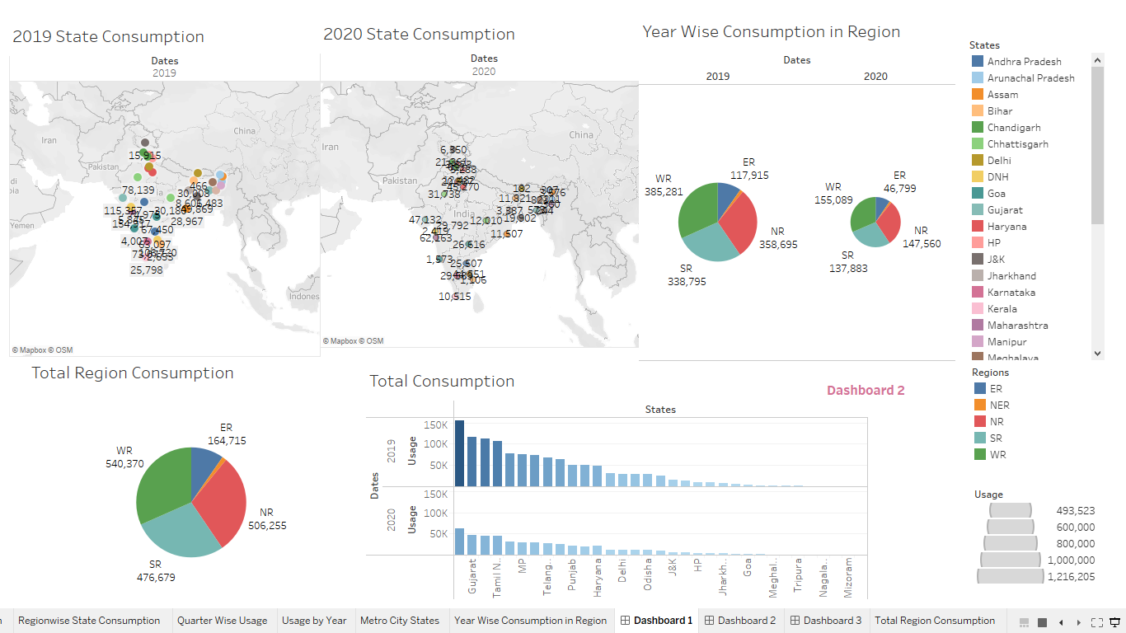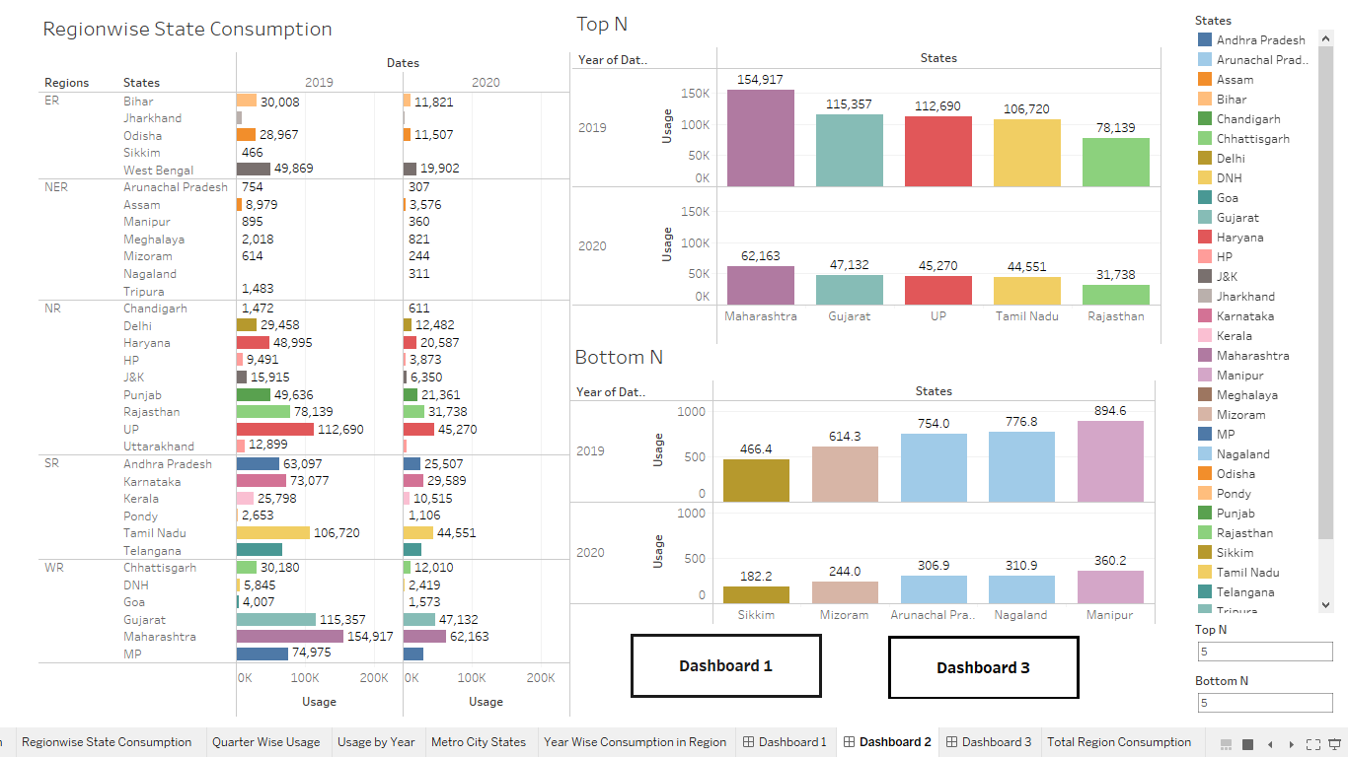

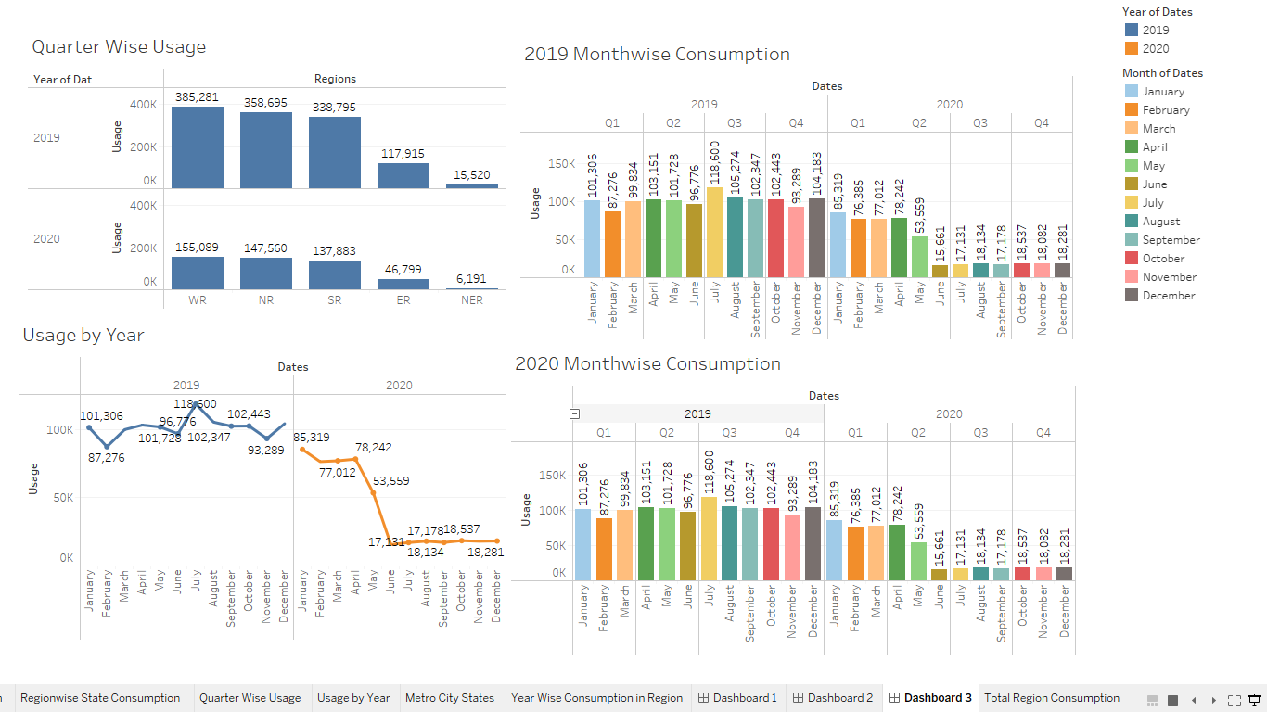

4. ADVANTAGES AND DISADVANTAGES

ADVANTAGES

* Improving the lifestyle of people living in areas without the access of electricity
* Reduce electricity wastage during transmission.
* Implementing the renewable source plans will help reduce the pollution .
* Using CFL bulbs will reduce consumption of electricity and we were able to conserve electricity.

DISADVANTAGES

* More power plants more pollution
* High cost of construction
* Natural seasonal changes affects the production of electricity

5. APPLICATIONS

* Solar panels can be constructed in Rajasthan as it has the highest potential to generate electricity.
* Wind mills can be construced in the Southern region of India.
* Usage of CFL BULBS can be implemented in residental and industrial areas which will lead to less consumption of electricity
* Hydroelectric power plants can be constructed in MAHARASHTRA.

6. CONCLUSION

Maharashtra is the highest electricity consumption user in India whereas Gujarat is the second highest. Sikkim is the lowest electricity consumption user of India. Western regions consumes highest energy whereas North eastern region is lowest.

7. FUTURE SCOPE

* Implementing government policies to promote and conserve electricity.
* Replacement of high electricity consumption bulbs with CFL bulbs and LED bulb .
* Construction of renewable power plants in areas with have higher potential to generate electricity.
* Maintenance of electricity conductors.
* Building higher transmission voltages and reducing resistance.

8. APPENDIX

A. Source code

